 | Atmosphere | Hydrosphere/  Cryosphere | Geosphere | Biosphere
Atmosphere | 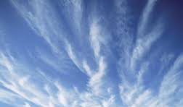 | Water evaporates from bodies of water into the atmosphere, condenses and form clouds, and precipitates | The air/wind can change the land through weathering and erosion over long periods of time. Tornadoes and high winds can quickly change the land. | Living things need gases in the atmosphere to live. Breathing/cellular respiration and photosynthesis also change the gases.
Hydrosphere/  Cryosphere | Draw a picture that shows water and air interacting. | 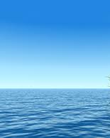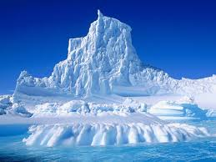 | Water can change the land through weathering and erosion. Floods, hurricanes, and tsunamis can quickly change the land. | Living things water to live. Water also provides shelter for aquatic animals.
Geosphere | Draw a picture that shows land and air interacting. | Draw a picture that shows land and water interacting. | 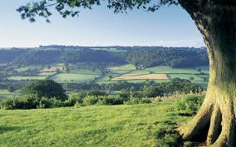 | Living things can change the land through their actions. The land also provides shelter for many living things.
Biosphere | Draw a picture that life and water and air interacting. | Draw a picture that shows life and water interacting. | Draw a picture that shows life and land interacting. | 